Exercise 1: Inventory Management System

**Approach & Understanding**

I have created a simple - easy to use Inventory Management System designed to allow Users to easily add, view and remove items from inventory.

**Code**

import java.util.ArrayList; import java.util.List;

import java.util.Scanner;

public class InventorySystem

{

static class Item

{

String n; int q; double p;

Item(String n, int q, double p)

{

this.n = n; this.q = q; this.p = p;

}

public String toString()

{

return "Item{name='" + n + "', qty=" + q + ", price=" + p + "}";

}

}

List<Item> list; Scanner s;

public InventorySystem()

{

list = new ArrayList<>();

s = new Scanner(System.in);

}

public static void main(String[] args)

{

System.out.println("inventory system"); InventorySystem x = new InventorySystem(); x.run();

}

public void run()

{

boolean e = false;

while (e == false)

{

System.out.println("1. Add"); System.out.println("2. view"); System.out.println("3. remove"); System.out.println("4. exit"); System.out.print("Type option: ");

int c = getNum();

if (c == 1)

{

add();

}

else if (c == 2)

{

view();

}

else if (c == 3)

{

remove();

}

else if (c == 4)

{

e = true;

System.out.println("exit.");

}

else

{

System.out.println("wrong option.");

}

}

s.close();

}

public void add()

{

System.out.print("name: "); String n = s.nextLine();

System.out.print("qty: "); int q = getNum();

System.out.print("price: "); double p = getDec();

Item it = new Item(n, q, p); list.add(it);

System.out.println("added.");

}

public void view()

{

if (list.size() == 0)

{

System.out.println("empty.");

}

else

{

for (Item i : list)

{

System.out.println(i);

}

}

}

public void remove()

{

System.out.print("name to remove: "); String n = s.nextLine();

boolean f = false;

for (int i = 0; i < list.size(); i++)

{

if (list.get(i).n.equalsIgnoreCase(n))

{

list.remove(i); f = true;

System.out.println("removed."); break;

}

}

if (f == false)

{

System.out.println("not found.");

}

}

public int getNum()

{

while (true)

{

try

{

return Integer.parseInt(s.nextLine());

}

catch (Exception e)

{

System.out.print("number: ");

}

}

}

public double getDec()

{

while (true)

{

try

{

return Double.parseDouble(s.nextLine());

}

catch (Exception e)

{

System.out.print("number: ");

}

}

}

}

**OUTPUT:**

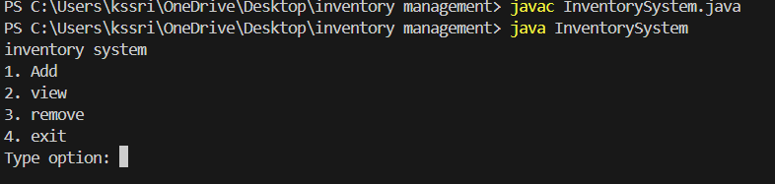

**ADD:**

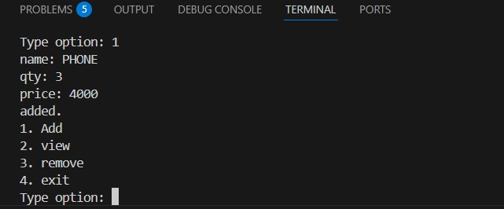

**VIEW:**

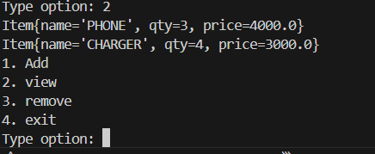

**REMOVE:**

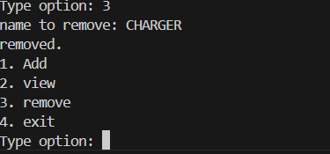

**EXIT:**

